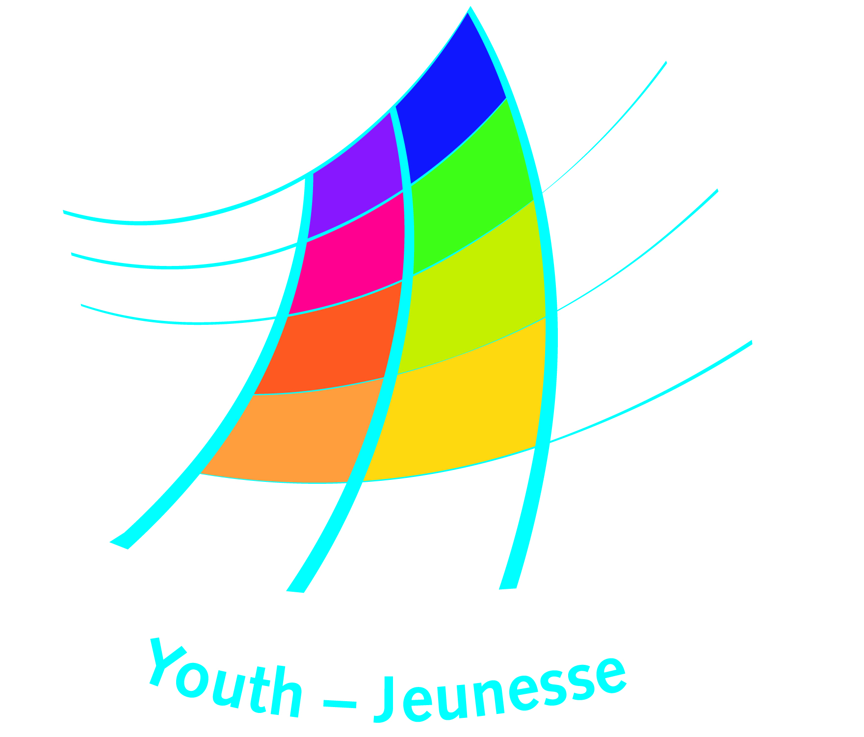
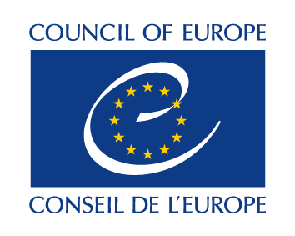

DDCP –YD/ NTC (2015)10E Strasbourg, 17 November 2015

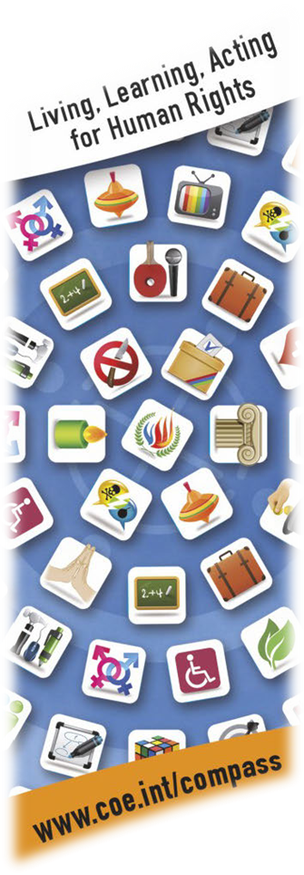

National Training Courses for Human Rights Education
With young people
Supporting the implementation of the Council of Europe Charter on Education for Democratic Citizenship and Human Rights Education through the training of non-formal learning trainers and multipliers at the national level.

Programme 2016

CALL FOR EXPRESSIONS OF INTEREST

Making human rights education real for every person in the Council of Europe

The work of the Youth Department of the Council of Europe on human rights education is a direct contribution of to the core mission of the organisation to promote and protect human rights. The project – often referred to as Human Rights Education Youth Programme - aims to consolidate and support the role of non-governmental youth organisations as actors in the implementation of the Council of Europe Charter on Education for Democratic Citizenship and Human Rights Education. It does so by combining the development and dissemination of tools and resources on human rights education and capacity-building activities for trainers, multipliers and advocates of human rights education and human rights.

The project was launched in 2000 with the aim to bring human rights issues in the mainstream of youth work and non-formal learning practice. It has been built around Compass, the manual for human rights education with young people, along with European training courses, support to national and regional training courses, pilot projects and study sessions carried out by youth organisations.

A fully revised version of Compass was published in 2012. The ‘new’ manual proposes a wider choice of activities to be realised with young people including a whole range of new topics such as Disability and Disablism, Religion, Remembrance, and Terrorism. The new Compass is being followed by translations so as to make it accessible to users in their working languages. In 2015, new language versions were made available in Arabic, French, Russian and Ukrainian, as well as the new online platform of the manual: www.coe.int/compass.

The Charter on Education for Democratic Citizenship and Human Rights Education, adopted by the Committee of Ministers of the Council of Europe in 2010, emphasises the role of member states of the Council of Europe in making human rights education a reality for every person in Europe and the importance of quality education to promote the core values of the institution. The Charter provides the basis for advancing human rights education at local and regional level by defining objectives and principles applying to policy, legislation and practice.

A survey on the implementation of the Charter was conducted among non-governmental organisations by the Youth Department in 2012. The survey revealed various challenges non-governmental organisations encounter when implementing the charter including; the lack of financial support, the lack of awareness of the role and importance of human rights education by policy makers and poor political support.
In 2016, the Council of Europe will initiate a new review of the Charter implementation, which will include a questionnaire addressed to governments and to civil society organisations. The aim of the review is to learn from existing practices and to establish directions of action for the upcoming years. The review is to be concluded in 2017 and to be presented in a conference dedicated to the Charter implementation co-organised by the Education and Youth Departments of the Council of Europe.

In 2015, the Committee of Ministers of the Council of Europe has decided to prolong for 3 years the No Hate Speech Movement Campaign in the framework of its ‘Action Plan against violent extremism and radicalisation leading to terrorism’. The campaign stands for human rights online and for developing the capacity of young people and youth organisations to counter hate speech and its root causes, racism and discrimination, both in the online and offline space. Human rights education will stay the main educational approach in the campaign, both at European and national level, notably through the usage of Bookmarks, the manual to combat online hate speech through human rights education.

National Training Courses in 2016

The programme of national (and regional) training courses in human rights education of the Youth Department continues in 2016 aiming to support the development of human rights education through youth work and non-formal learning. The courses are organised at the initiative of national organisations or institutions interested in introducing, and developing the provisions and quality of human rights education.
With this call, the Council of Europe’s Youth Department invites for expressions of interest for national training courses to be held in 2016 in accordance with the criteria and priorities outlined below.

1. General criteria - format of the courses

- All training courses should aim to develop the competences (knowledge, skills, attitudes and values) of key multipliers for human rights education such as youth leaders, trainers, youth workers, teachers and teacher trainers.
- The follow-up of the training course should ensure measures to support the development or strengthening of national networks of organisations and trainers involved in human rights education with young people.
- The programme and methodology of the training courses should be based on the approaches outlined in Compass. An introduction to Compass and its approaches; experience in using the manual and how to adapt it to the participants’ contexts should be central to the course.
- Participants in the training courses should be provided with copies of Compass in their language(s), where this is possible.
- The programme of the activity should include a reflection on the Council of Europe Charter on Education for Democratic Citizenship and Human Rights Education and the role of participants in using it as an instrument for advocacy.
- The courses’ organisers should link with and build upon previous initiatives, projects and programmes on human rights education with young people at national level and the participants must be recruited from a diversity of organisations and institutions.
- The courses should consider space for cooperation with and inclusion of the work of the national coordinators of Education for Democratic Citizenship or other relevant bodies in charge of supporting the implementation of the Council of Europe EDC/HRE Charter;
- Participants should be committed to carry out further activities and projects in human rights education and should be in a position to do so within their organisations or institution.
- The duration of the courses should be a minimum of 4 consecutive working days.
- The number of participants should be a minimum of 15 and maximum 40.
- The duration of the course, the number of participants and their profile should be consistent with the objectives and programme of the course.
- All training courses should take place between 1 February and 31 October 2016.

2. Priority criteria

Priority will be given to those proposals that:
- are organised in co-operation with one or more partner organisations;
- have a clear plan to build or strengthen national networks of organisations and trainers involved in human rights education with young people;
- support advocacy for human rights education through the Charter on Education for Democratic Citizenship and Human Rights Education;
- are being held in countries where newly published translations of COMPASS can be introduced to key multipliers (e.g. trainers, youth leaders, school teachers, etc.)
- are being held in countries where no similar course has been organised in the past two years;
- involve cooperation between the non-formal and formal educational sectors and actors;
- link with the No Hate Speech Movement campaign at national level.
- are being held in the first half of 2016.

3. Eligible applicants

Proposals are welcome from:
- non-governmental youth organisations and/or other non-governmental organisations;
- governmental organisations primarily those focused on human rights, youth and/or education;
- institutions involved in human rights education;
- national networks of human rights activists and/or human rights educators.

4. Role and commitments of the course organisers

The course organisers are expected to:
- define the objectives for the training course relevant to the specific context of the country or region;
- prepare, run and evaluate the training course with a competent team of trainers and organisers and use the approaches and methodology for human rights education outlined in Compass, ensuring a participatory educational setting;
- include, where appropriate and possible, in the team of trainers one or more trainers who have participated in one of the Training of Trainers in Human Rights Education courses organised by the Youth Department of the Council of Europe;
- ensure that participant recruitment is done through an open and widely disseminated call for participants;
- ensure the organisation of at least one preparatory meeting of the training course involving the entire team of trainers;
- provide the logistical infrastructure for a residential training seminar;
- ensure that participants in the training course receive a copy of the translation of Compass manual in their working language/s and, if not available, in English, French or Russian. Where relevant, the training course coordinators are expected to consult and coordinate in this respect with the publishers of Compass translations;

Support by the Council of Europe

The programme of activities of the Youth Department of the Council of Europe foresees full support (financial, educational and institutional) to a maximum of 5 training courses in 2016. The conditions applying to the support are outlined below. Course organisers are encouraged to fully take these conditions into account before applying. The support of the Council of Europe should be complemented by resources from other partners, contributing to the sustainability of the actions.

Educational support and advice

The Youth Department can recommend or contract a trainer(s) with relevant experience to be part of the team of trainers responsible for the programme implementation. When contracted by the Council of Europe, the costs regarding fees and travel of the trainer will covered by the Youth Department. The trainer will be directly selected and contracted by the Youth Department through its Trainers’ Pool. Alternatively, the Youth Department may provide support via one of its Educational Advisors.

Financial support

The Youth Department may cover directly, full or partial, costs of a course such as:
- board and lodging of participants and preparatory team;
- local travel costs;
- interpretation costs, if necessary and justified;
- publication and printing of educational materials relevant for the training course;
- costs related to personnel (staff) of the organisation working directly on the project (not trainers/consultants), up to a maximum of 10% of the total amount requested from the Council of Europe;
- administrative costs up to a maximum of 5% of the total amount requested from the Council of Europe and up to an absolute maximum of 300 euro.

The overall contribution requested from the Council of Europe cannot exceed 7.000 Euros; most often, the financial support is between 4.000 and 6.000 Euros.

The financial assistance cannot cover fees for trainers contracted by the applicant.

The courses benefiting from financial support, will engage in an administrative arrangement with the Youth Department of the Council of Europe. The amount of the arrangement will be paid to the organisers in two instalments:
- 70% of the amount within 30 days from the receipt of the Administrative Arrangement duly signed by the organisers;
- The balance within 30 days of the receipt and approval of the narrative and financial report.
The course organisers should be ready to provide 3 competitive offers for any services or goods costing more than 2.000 Euros.

Institutional support

The Youth Department can provide, upon request:
- recommendation letters to potential partners and funders;
- official Council of Europe representation at parts of the training course programme;
- links with the Council of Europe Field Offices (where relevant) and with governmental and non-governmental partners of the Council of Europe in Youth and Education sectors;
- visibility of the training courses on its websites;
- usage of the logos of the Council of Europe;
- provide and co-sign certificates of participation;
- support with educational and information materials of the Council of Europe;
- support the communication with publishers of Compass and Compasito translations.

Selection procedure and deadlines

All expressions of interest must be sent to the Youth Department using the appended form by email before 16 December 2015 to dys.nrtc@coe.int. Partners will be informed about the results by 31 January 2016.

For further information and questions, please contact: dys.nrtc@coe.int

Further information on Human Rights Education Youth Programme and other programmes of the Youth Department can be found at http://www.coe.int/youth.

National Training Courses for Human Right Education
With young people
FORM FOR EXPRESSION OF INTEREST
in organising a national course

Please type in English or French and answer all questions clearly and concisely. Add extra lines or pages as needed, but please keep to the order of questions.

1. Name of the applicant organisation(s):

2. Details of the organisation(s)*

Address (include city, postal code, and country):
Telephone (include international dialling code):
Fax number:
Email:
Website:

3. Contact person. Please provide the name and contact details of the person in charge of the project:
Name:
Position in the organisation:
Address:
Telephone number:
Email:

Are you cooperating with any other organisation(s) in making this request? If so, please give details of the organisation, their profile and a contact person:

4. Title, time, working language and duration of the training course (training courses must be a minimum of 4 consecutive working days in duration):

4a. Title of the course:

4b. Start date:

4c. End date:

4d. Number of working days:

4e. Working Language(s) of the course:

5. Venue (if possible, provide the address)

6. Participants in the training. Please provide details about:

6a. Profile of participants:

6b. Number of participants (the accepted minimum is 15 and the maximum 40):

6c. Expected average age of participants:

6d. Place of residence of participants:

6e. Relationship of participants with your organisation:

6f. Explain in detail the planned procedure and calendar for recruitment and criteria for selection of the participants:

7. Probable composition of the team of trainers

Name of trainer | Organisation | Competences or experience (in relation to the course)

8. What are the aims and objectives of the training course?

9. Competences addressed by the training course
What knowledge, skills and attitudes do you plan to develop through the course?

10. Programme outline and methodology
Please provide a provisional outline of the programme envisaged and a description of the methodology to be used.

11. Preparation
Please outline the preparation process planned for this course, including any preparatory meetings foreseen and explain how the trainers’ team will be involved in the preparation process.

12. Follow-up

- What follow-up do you expect participant to undertake as a result of the course? How will the participants be supported in their future projects and follow-up activities?

- How will your organisation follow-up on the training course? How will you support the development/strengthening of national networks of organisations and trainers involved in human rights education?

13. Expected impact
What is the expected impact of the training in your country in relation to human rights education? How will it relate with the Charter for Education for Democratic Citizenship and Human Rights Education?

15. Type of support you request from the Youth Department (multiple choices are possible):

Educational support and advice:

Trainer contracted by the Council of Europe

Trainer recommended by the Council of Europe (and paid for by the organisers)

Institutional support, please specify:

Financial assistance
If yes, please submit your detailed budget proposal using the table below (appendix 1).

Please submit this form to:

Council of Europe, Youth Department
E-mail: dys.nrtc@coe.int
Before 16 December 2015

APPENDIX 1
To be filled out only by applicants requesting financial support.
Please present, using the table below, a detailed budget of the expenses and income of your project, indicating the amount and purpose of the support requested from the Council of Europe Youth Department. The budget must be submitted in Euro (€) and the total expenses must match the total income expected. Please add extra rows to the table as needed.

Bank details (please submit details for your EUR account)
Bank account holder:
Bank name:
Bank address:
IBAN/ Bank account number:

SWIFT code:

Costs | Unit | # of units | Average unit rate (€) | # of participants |  | Estimated  budget (€) | Council of Europe contribution | Contribution from other sources – (specify)
1. Per diems ¹
1.1 Hotel expenses (nights x unit rate x participants) | Per night
1.2. Meals (meals x unit rate x participants ) | Per meal
1.3 Coffee breaks (breaks x unit rate x participants) | Per break
Subtotal Per diems
2. Travel
2.1 National participants (return trip x unit rate x participants) | Per trip
2.2 Local transport (coach hire) | Per day
Subtotal Travel
3. Rent of hall, interpretation and translation
3.1 Rent of hall/training room (days x unit rate) | Per day
3.2 Rent of interpretation equipment (days x unit rate) | Per day
3.3 Interpretation services (days x unit rate x interpreters) | Per day
3.4 Translation (pages x unit rate) | Per page
Subtotal Rent of hall, interpretation and translation
4. Publications and printed material
4.1 Publications (editing) (item x unit rate) | Per item
4.2 Publications (printing) (item x unit rate x copies) | Per item
Subtotal Publications and printed material
5. Other (specify)
5.1. specify | specify
5.2 specify | specify
Subtotal Other
6. Administrative fees
6.1 Stationery supplies | Per event
6.2 Other services (tel/fax, mail, copies) | Per event
Subtotal Administrative fees
Total:

The Council of Europe Charter on Education for Democratic Citizenship and Human Rights Education is available at: http://www.coe.int/t/dg4/education/edc/Charter/Charter_EN.asp
The Youth Department welcomes, as well, proposals for regional training courses. The regional training courses are to be understood as either regional within one country if particular conditions make this option more feasible (i.e. size or language) or between two or more countries, especially if language allows it.
The list of National and Regional Training Courses organised in 2014-2015: Albania, Andorra, Armenia, Belarus, Estonia, France, Georgia, Greece, Hungary, Italy, Malta, Russian Federation, Spain, and Ukraine.
* Please supply details of aims, membership, structures and activities of your organisation in addition to this form.
You can include here in the number of participants also the team members and members of the organising team.

